**Practical No. 06**

**TITLE:** EASY GUI USING ANDROID STUDIO

**AIM:** IMPLEMENT EASY GUI USING ANDROID STUDIO

**APPARATUS:** ANDROID STUDIO

**THEORY:**

* **activity_main.xml**

<?xml version="1.0" encoding="utf-8"?>

<LinearLayout

xmlns:android="http://schemas.android.com/apk/res/android"

xmlns:app="http://schemas.android.com/apk/res-auto"

android:layout_width="match_parent"

android:layout_height="match_parent"

android:orientation="vertical"

android:background="@drawable/bg">

<RelativeLayout

android:layout_width="match_parent"

android:layout_height="wrap_content"

android:padding="30dp">

<TextView

android:id="@+id/hello"

android:layout_width="wrap_content"

android:layout_height="wrap_content"

android:text="Hello,"

android:textColor="#fff"

android:textSize="20dp"/>

android:textSize="20dp"/>

<TextView

android:layout_width="wrap_content"

android:layout_height="wrap_content"

android:text="USER"

android:textColor="#fff"

android:textStyle="bold"

android:fontFamily="sans-serif-black"

android:textSize="26dp"

android:layout_below="@id/hello"

android:layout_marginTop="10dp"/>

<Button

android:layout_width="70dp"

android:layout_height="70dp"

android:layout_alignParentRight="true"

android:background="@drawable/profile"/>

<RelativeLayout

android:id="@+id/r1"

android:layout_width="match_parent"

android:layout_height="wrap_content"

android:background="@drawable/search_bg"

android:layout_marginTop="100dp">

<ImageView

android:layout_width="20dp"

android:layout_height="20dp"

android:src="@drawable/search_img"

android:layout_alignParentLeft="true"

android:layout_centerVertical="true"

android:layout_marginLeft="20dp"/>

**Conclusion:** Thus we implemented the installation o

<TextView

android:layout_width="wrap_content"

android:layout_height="wrap_content"

android:text="Search"

android:layout_marginLeft="55dp"

android:layout_centerVertical="true"

android:textSize="18dp"

android:textColor="#03082b"/>

<ImageView

android:layout_width="20dp"

android:layout_height="20dp"

android:src="@drawable/arrow_bottom"

android:layout_alignParentRight="true"

android:layout_centerVertical="true"

android:layout_marginRight="20dp"/>

</RelativeLayout>

</RelativeLayout>

<LinearLayout

android:layout_width="match_parent"

android:layout_height="wrap_content"

android:orientation="horizontal">

<RelativeLayout

android:layout_width="wrap_content"

android:layout_height="wrap_content">

<ImageView

android:id="@+id/backend"

android:layout_width="200dp"

android:layout_height="300dp"

android:src="@drawable/backend"

android:layout_marginLeft="5dp"/>

<TextView

android:layout_width="wrap_content"

android:layout_height="wrap_content"

android:text="Backend"

android:textSize="25dp"

android:textColor="#d703082b"

android:textStyle="bold"

android:layout_marginLeft="40dp"

android:layout_marginTop="40dp"/>

<TextView

android:layout_width="wrap_content"

android:layout_height="wrap_content"

android:text="12 Courses"

android:textSize="14dp"

android:textColor="#ab03082b"

android:textStyle="bold"

android:layout_marginLeft="40dp"

android:layout_marginTop="70dp"/>

</RelativeLayout>

<RelativeLayout

android:layout_width="wrap_content"

android:layout_height="wrap_content">

<ImageView

android:id="@+id/frontend"

android:layout_width="200dp"

android:layout_height="300dp"

android:src="@drawable/frontend"/>

<TextView

android:layout_width="wrap_content"

android:layout_height="wrap_content"

android:text="Frontend"

android:textSize="25dp"

android:textColor="#d703082b"

android:textStyle="bold"

android:layout_marginLeft="35dp"

android:layout_marginTop="40dp"/>

<TextView

android:layout_width="wrap_content"

android:layout_height="wrap_content"

android:text="17 Courses"

android:textSize="14dp"

android:textColor="#ab03082b"

android:textStyle="bold"

android:layout_marginLeft="35dp"

android:layout_marginTop="70dp"/>

</RelativeLayout>

</LinearLayout>

<RelativeLayout

android:layout_width="match_parent"

android:layout_height="wrap_content">

<TextView

android:layout_width="wrap_content"

android:layout_height="wrap_content"

android:text="Courses List (3)"

android:textColor="#03082b"

android:textStyle="bold"

android:textSize="20dp"

android:layout_marginLeft="23dp"/>

<ImageView

android:id="@+id/img213456"

android:layout_width="40dp"

android:layout_height="40dp"

android:background="#78F137"

android:src="@drawable/ic_baseline_navigate_next_24"

android:layout_alignParentRight="true"

android:layout_centerVertical="true"

android:layout_marginRight="20dp"/>

</RelativeLayout>

<RelativeLayout

android:layout_width="match_parent"

android:layout_height="wrap_content">

<ImageView

android:id="@+id/javascript"

android:layout_width="380dp"

android:layout_height="80dp"

android:background="@drawable/cv4"

android:layout_marginRight="20dp"

android:layout_marginLeft="18dp"

android:layout_marginTop="10dp"/>

<ImageView

android:layout_width="50dp"

android:layout_height="50dp"

android:src="@drawable/c4"

android:layout_marginLeft="35dp"

android:layout_centerVertical="true"/>

<TextView

android:layout_width="wrap_content"

android:layout_height="wrap_content"

android:text="JavaScript"

android:textSize="20dp"

android:textStyle="bold"

android:textSize="20dp"

android:textStyle="bold"

android:textColor="#d703082b"

android:layout_marginLeft="105dp"

android:layout_marginTop="20dp"/>

<TextView

android:layout_width="wrap_content"

android:layout_height="wrap_content"

android:text="4 Hours, 20 Minutes"

android:textSize="14dp"

android:textStyle="bold"

android:textColor="#6003082b"

android:layout_marginLeft="105dp"

android:layout_marginTop="50dp"/>

</RelativeLayout>

<RelativeLayout

android:layout_width="match_parent"

android:layout_height="wrap_content"

android:layout_marginTop="3dp">

<ImageView

android:id="@+id/design"

android:layout_width="380dp"

android:layout_height="80dp"

android:background="@drawable/cv2"

android:layout_marginRight="20dp"

android:layout_marginLeft="18dp" />

<ImageView

android:layout_width="50dp"

android:layout_height="50dp"

android:src="@drawable/c2"

android:layout_marginLeft="35dp"

android:layout_centerVertical="true"/>

<TextView

android:layout_width="wrap_content"

android:layout_height="wrap_content"

android:text="Responsive Design"

android:textSize="20dp"

android:textStyle="bold"

android:textColor="#d703082b"

android:layout_marginLeft="105dp"

android:layout_marginTop="10dp"/>

<TextView

android:layout_width="wrap_content"

android:layout_height="wrap_content"

android:text="4 Hours, 20 Minutes"

android:textSize="14dp"

android:textStyle="bold"

android:textColor="#6003082b"

android:layout_marginLeft="105dp"

android:layout_marginTop="40dp"/>

</RelativeLayout>

</LinearLayout>

* **MainActivity.java**

package com.example.easylearning;

import androidx.appcompat.app.AppCompatActivity;

import android.annotation.SuppressLint;

import android.content.Intent;

import android.os.Bundle;

import android.view.View;

import android.widget.ImageView;

import android.widget.Toast;

public class MainActivity extends AppCompatActivity {

private ImageView imageView, backend, frontend, javascript, design;

@SuppressLint("MissingInflatedId")

@Override

protected void onCreate(Bundle savedInstanceState) {

super.onCreate(savedInstanceState);

setContentView(R.layout.activity_main);

backend=findViewById(R.id.backend);

frontend=findViewById(R.id.frontend);

javascript=findViewById(R.id.javascript);

design=findViewById(R.id.design);

imageView=findViewById(R.id.img213456);

imageView.setOnClickListener(new View.OnClickListener() {

@Override

public void onClick(View v) {

openhome();

}

});

backend.setOnClickListener(new View.OnClickListener() {

@Override

public void onClick(View v) {

Toast.makeText(MainActivity.this, "12 Courses Available", Toast.LENGTH_SHORT).show();

}

});

Toast.makeText(MainActivity.this, "12 Courses Available", Toast.LENGTH_SHORT).show();

}

});

frontend.setOnClickListener(new View.OnClickListener() {

@Override

public void onClick(View v) {

Toast.makeText(MainActivity.this, "17 Courses Available", Toast.LENGTH_SHORT).show();

}

});

javascript.setOnClickListener(new View.OnClickListener() {

@Override

public void onClick(View v) {

Toast.makeText(MainActivity.this, "Course Duration 260 Minutes", Toast.LENGTH_SHORT).show();

}

});

design.setOnClickListener(new View.OnClickListener() {

@Override

public void onClick(View v) {

Toast.makeText(MainActivity.this, "Course Duration 260 Minutes", Toast.LENGTH_SHORT).show();

}

});

}

public void openhome(){

Intent intent = new Intent(this, home.class);

startActivity(intent);

}

}

* **Project Files –**

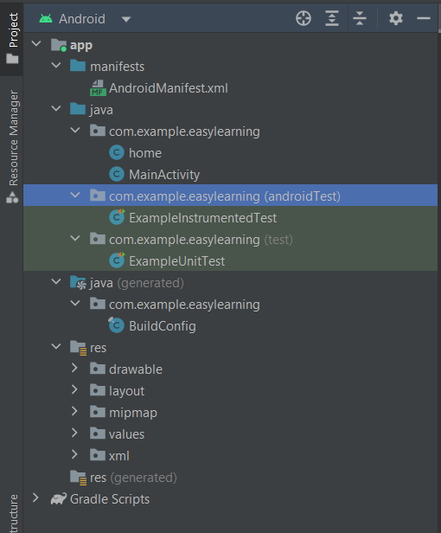

* 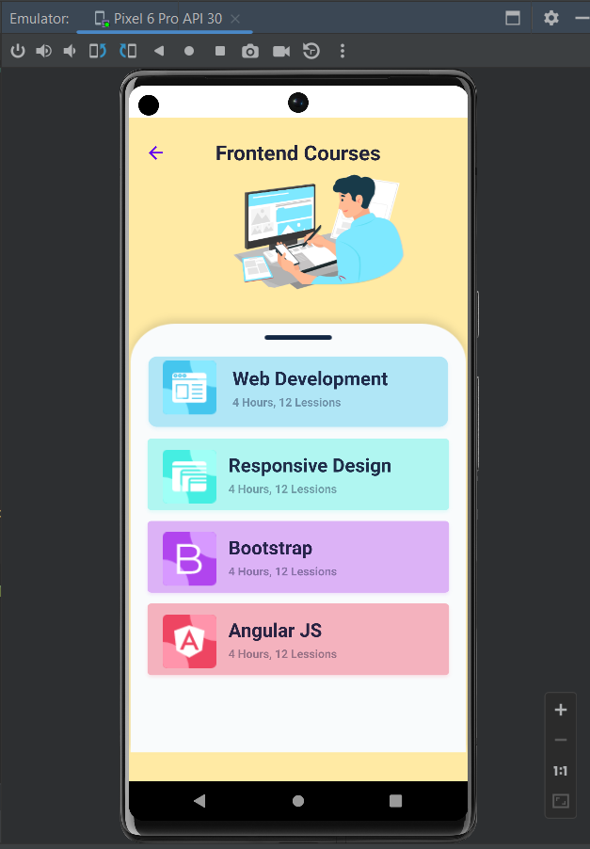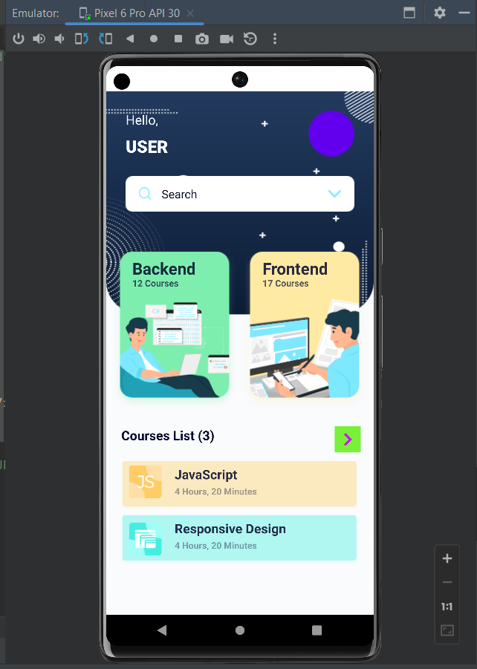**Output on Emulator –**

**Conclusion:** Thus we studied the implementation of Easy GUI in Android Studio.